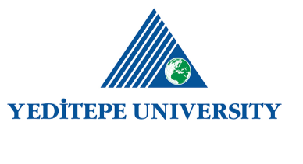
DEPARTMENT OF NURSING EDUCATION POLICY

As Yeditepe University Faculty of Health Sciences Nursing Department, our educational processes are based on; student-centered education, research-based approaches, innovative teaching techniques, lifelong learning and internationalization.
Our department, which adopts the continuity and development of modern science and nursing education carried out with the belief of serving the society based on Atatürk's principles and the Renaissance of the Republic, as the basic principle; It carries out its academic and social activities by adhering to the values of protecting the freedom of thought, expression and conscience, acting equally and fairly, ensuring open communication and being transparent, ensuring safety, protecting health, taking care not to harm material and moral assets, and providing continuous improvement and development . In accordance with the “Planning-Implementation-Controlling-Precaution (PUKÖ)” cycle, educational activities are followed and necessary improvements and developments are implemented. In this context, our Education-Training policy document provides a framework for the management, support and development of educational activities to be carried out in our department.
In line with our education policy, our department;
- Aims to train nurses who have scientific perspective, critical thinking and communication skills, are open to innovations, and qualified in health care at national and international level.
- Conducts a versatile and international education and training program that is compatible with national core programs covering care, education, management and research in nursing, in accordance with accreditation processes, and meets international equivalence requirements.
- Students; It provides guidance for their professional and personal development in accordance with the lifelong learning principle by supporting their participation in club activities, extracurricular learning activities, sports activities, scientific programs and research, DEP/MINOR programs, certificate programs and exchange programs such as Erasmus+ .
- Students; Academic Counseling in the field of education in order to plan, identify problems and provide solutions; Peer Counseling in order to provide psychological and social support in curricular/extracurricular issues, to increase interaction and to facilitate adaptation to the university/department; and carries out Career Counseling systems to assist students in their career planning.
- Makes academic staff planning in line with the needs of the department; It conducts the program with qualified (expert in the field, fluent in foreign language, effective use of innovative learning and teaching techniques) and sufficient number of instructors.
- Encourages the instructors to follow up-to-date information, supports the participation of the instructor in the training of trainers and the trainings specific to the field of specialization of the instructor.
- Gives importance to student satisfaction; receives feedback from students on theoretical courses, clinical applications, instructors, learning environments, teaching methods, measurement and evaluation methods, and physical infrastructure and plans necessary improvements.
- Continuously improves its education and training processes by strengthening national and international collaborations with the participation of stakeholders.

